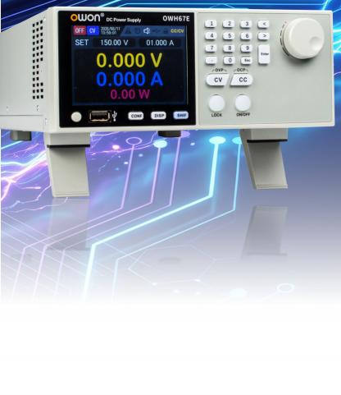
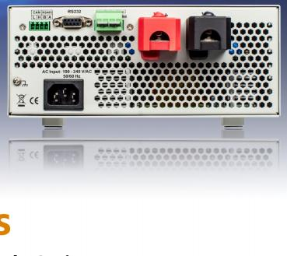
OWH67E Series

Programmable DC Power Supply Series

Features
● 1/2 2U chassis with rear outputs for rack integration.
● Wide-range AC input and 1,000 W constant-power output, with 60 A/120 A models ideal for low-voltage, high-current testing.
● 10 mV/1 mA setting and readback resolution.
● 100-step LIST programming with PC control.
● CV/CC priority switching for different load requirements.
● Built-in discharge circuit removes residual voltage after shutdown for safer operation.
● Built-in SAS model supports EN 50530 and Sandia PV curves for MPPT efficiency testing.

● Digital control with OVP, OCP, OPP, OTP, and other protections.
● Standard RS232/RS485 interfaces support the Modbus protocol and SCPI commands for remote control and automated testing.
● 3.9-inch TFT color LCD with output curves and 1-minute data logging.

Specifications
Specifications are guaranteed after a 30-minute warm-up at the specified temperature.

  Model  AC Input (Voltage/Frequency) |  | OWH67E010-60  OWH67E010-150
 |  | 100-240Vac；50-60Hz
Rated Output (0 °C to 40 °C) | Voltage | 0-150V | 0-60V
Rated Output (0 °C to 40 °C) | OVP | 155V | 65V
Rated Output (0 °C to 40 °C) | Current | 0-60A | 0-120A
Maximum Output Power |  | 1000W
Load Regulation* | Voltage | ≤30mV | ≤30mV
Load Regulation* | Current | ≤30mA | ≤30mA
Line Regulation | Voltage | ≤20mV | ≤20mV
Line Regulation | Current | ≤20mA | ≤20mA
Settings Resolution |  | 10mV/1mA
Readback Resolution |  | 10mV/1mA
Settings Accuracy (% of output + offset) | Voltage | ≤0.1%+0.1%FS | ≤0.1%+0.1%FS
Settings Accuracy (% of output + offset) | Current | ≤0.1%+0.1%FS | ≤0.1%+0.1%FS
Readback Accuracy  (% of output + offset) | Voltage | ≤0.1%+0.1%FS | ≤0.1%+0.1%FS
Readback Accuracy  (% of output + offset) | Current | ≤0.1%+0.1%FS | ≤0.1%+0.1%FS
Ripple & Noise  (20 Hz to 20 MHz) | Voltage | ≤ 150mVp-p | ≤ 150mVp-p
Ripple & Noise  (20 Hz to 20 MHz) | Current(rms) | ≤60mA | ≤ 120mA
Output Temperature Coefficient (0℃-40℃) |  | 100 ppm/°C (Voltage); 200 ppm/°C (Current)
Readback Temperature Coefficient |  | 100 ppm/°C (Voltage); 200 ppm/°C (Current)
Recovery Time (10% to 90% Load) |  | ≤ 5.0ms
Display |  | 3.9-inch TFT Color LCD
Interface |  | RS232, RS485, and CAN Parallel Operation
Dimensions (W × H × D, mm) |  | 214*88*374
Weight (kg) |  | Approx. 6.3 kg
*: Voltage load regulation is measured at the remote sense terminals. Specifications subject to change without prior notice.
Ordering Information

Ordering Information |  |  | Order No.
Main Unit
0-150V ，0-60A， | 1000W， | 1CH | OWH67E010-150
0-60V ，0-120A， | 1000W， | 1CH | OWH67E010-60
Standard Accessories
Quick Guide |  |  | ————
Power Cord (Local Standard) |  |  | ————
RS485/CAN Communication Terminal Block |  |  | 7Term-3
Remote Sense Terminal Block |  |  | 7Term-4
Optional Accessories
40A Test Leads |  |  | 7T2T40
80A Test Leads |  |  | 7T2T80
120A Test Leads |  |  | 7T2T120
L-Shaped Mounting Bracket |  |  | 7L-B
Warranty
1-year main-unit warranty; accessories excluded.

Fujian Lilliput Optoelectronics Technology Co., Ltd.
No. 19, Heming Road, Lantian Industrial Zone Zhangzhou 363005 P.R. China Tel : +86.596.213.0430 E-mail: info@owon.com.cn www.owon.com

